Brandon Dooley

Dooleyb1@tcd.ie

Date of Experiment: 25/11/2016

Lab Session: 14:00-16:00

*All circuit diagrams created using CircutDiagram*

*© 2016 Circuit Diagram*

Brandon Dooley ( #16327446 )

CS1025 Laboratory Experiment 2

CS1025 Laboratory Experiment 2

# Objective

* To investigate the effects that diode(s) have on a.c voltage. (Part One)
* To investigate the effects on a.c voltage when a d.c source is also applied. (Part Two)
* To investigate the effects an LED has on the above voltage. (Part Two)

# Method (Part One)

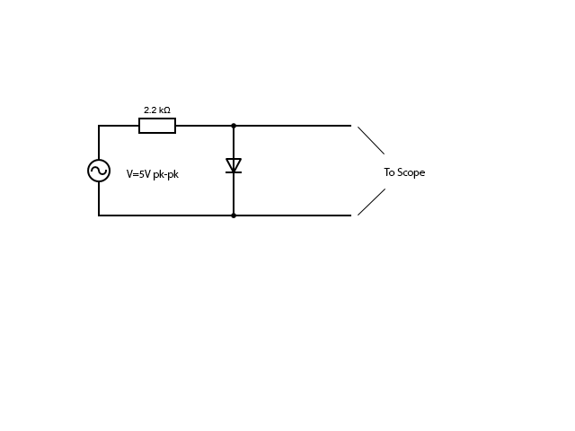 ***Fig 1.1***

1. The apparatus was set up as shown in *Fig 1.1*, with a 2.2kΩ resistor connected in series with a standard diode. The circuit was then connected to a 5V pk a.c power source and current was allowed to flow through the circuit. Using an oscilloscope, the voltages flowing through the circuits was observed and the results recorded.

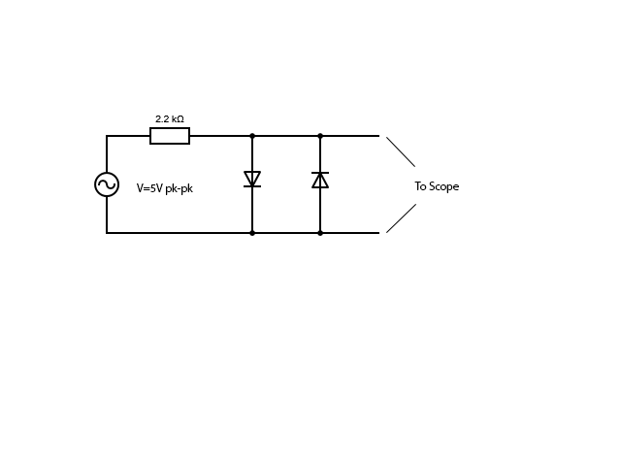 ***Fig 1.2***

1. The circuit was then changed and another standard diode was placed in parallel with the one seen above in *Fig 1.1*. The bias of the second diode was set opposite to that of the first. The circuit was then connected to a 5V pk a.c power source and current was allowed to flow through the circuit. Using an oscilloscope the voltages flowing through the circuits were observed and the results recorded. The resulting voltages before and after the second diode on the oscilloscope were then compared.

# Results (Part One)

1. 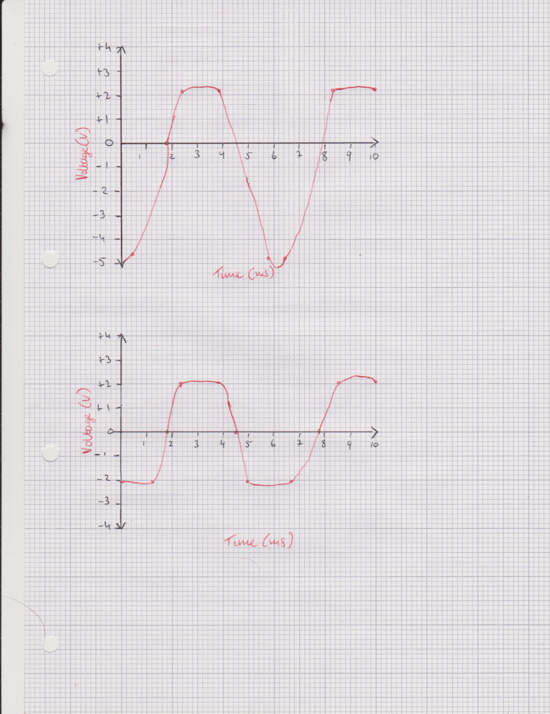
2. 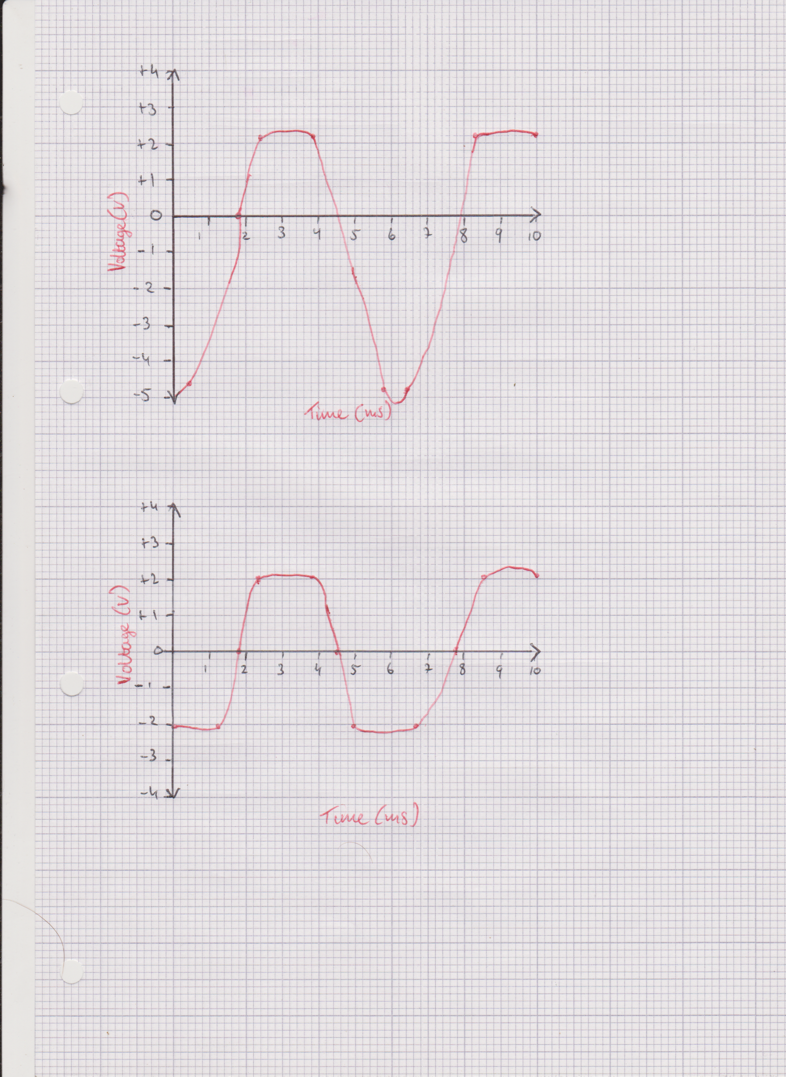

# Analysis (Part One)

* From **a)** it can be determined that when an a.c source is applied to the circuit in *Fig 1.1* the voltage oscillated normally in the bottom half of the oscilloscope (sinusoidal curve). However, when it changes direction and rises above the 0V line (top half) it levels off and continues at a somewhat constant rate.
* From **b)** it can be determined that when another diode is placed in parallel and an a.c source is applied to the new circuit in *Fig 1.2* the voltage oscillation is disrupted on both halves of the oscilloscope. The voltage doesn’t change in a sinusoidal manner. The voltage also never reaches the peak voltage of 5V.

# Uncertainty & Error (Part One)

* Errors when calibrating a zero reference for the oscilloscope
* Errors when choosing voltages and frequencies on the function generator
* Power lost through other energy conversions e.g heat
* Internal resistance of devices e.g the oscilloscope impacting readings

# Conclusions(Part One)

* **a)** The bottom half of the oscilloscope represents when the diode is in reverse biased and smoothly allows the a.c voltage to oscillate in its natural sinusoidal manner. However, when the a.c voltage changes direction the diode is now considered to be forward biased and it eventually allows current to flow. This can be seen where the oscilloscope levels off. This is known as the cut-in voltage of the diode. From the graph the estimated cut-in voltage was approx. 2.2V.
* **b)** When the second diode is placed in parallel with the first diode the graph changes greatly. This time the cut-in voltage can be seen on both the positive and negative side of the scope. This is because at some stage one of the diodes will be forward biased and will allow current to flow. The cut in voltage of the diodes can be approximated to +/-2.2V from the graph.

# 

# Method (Part Two)

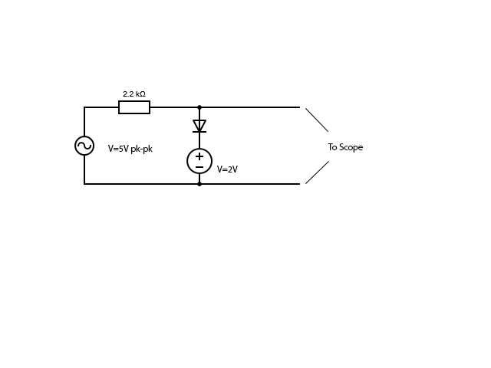***Fig 2.1***

1. The apparatus was set up as shown in *Fig 2.1* with a 2.2kΩ resistor connected in series to a forward biased diode as seen in *Fig 1.1*. However, this time a 2V d.c source was also connected in series as seen above. Using an oscilloscope, the voltages flowing through the circuit was observed and the results recorded. The results were then compared to the voltage without the d.c source as seen in Part One (*Fig 1.1)*

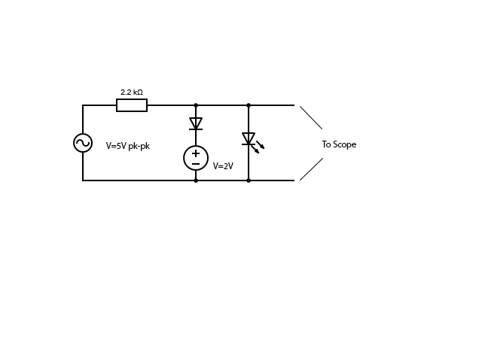 ***Fig 2.2***

1. The circuit was then further changed and an LED was connected in parallel to the first diode and d.c source. This LED was biased in the same direction as the first diode. The oscilloscope was then connected to the new circuit and both of the sources turned on. The new resulting voltages were observed and recorded. They were then compared to the previous voltages.

# Results (Part Two)

**c)**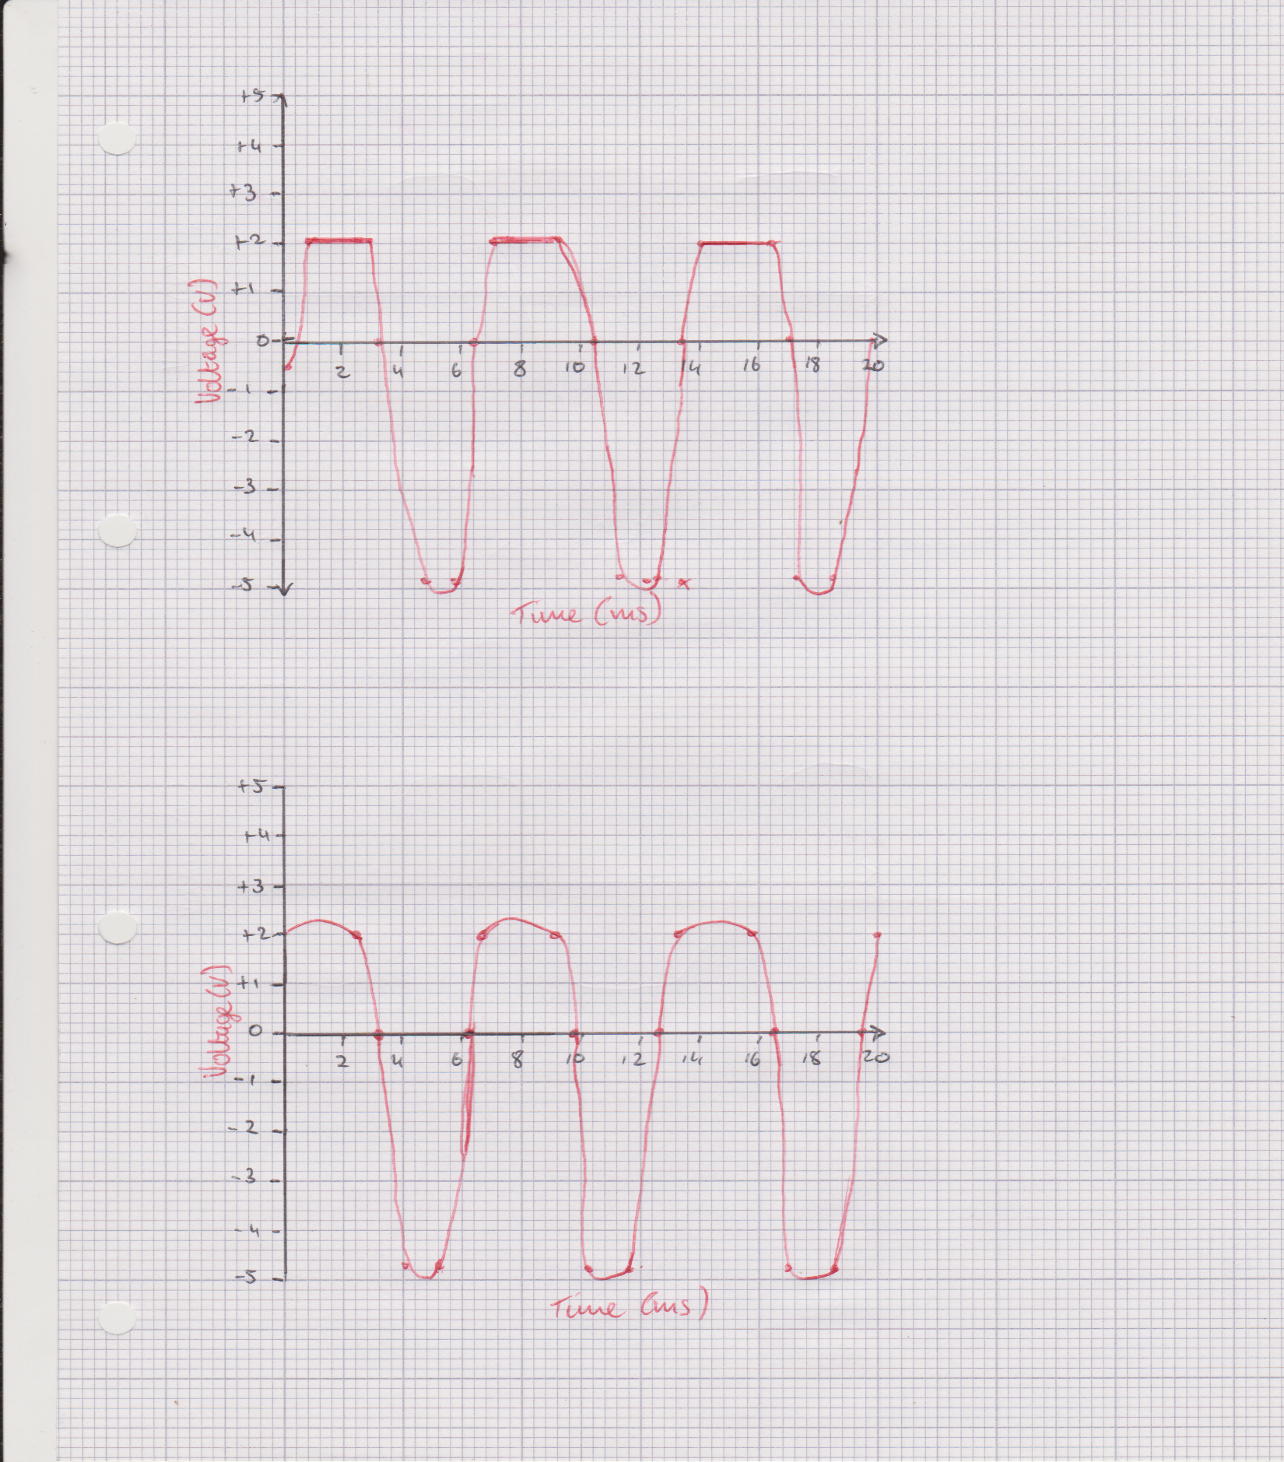

**d)**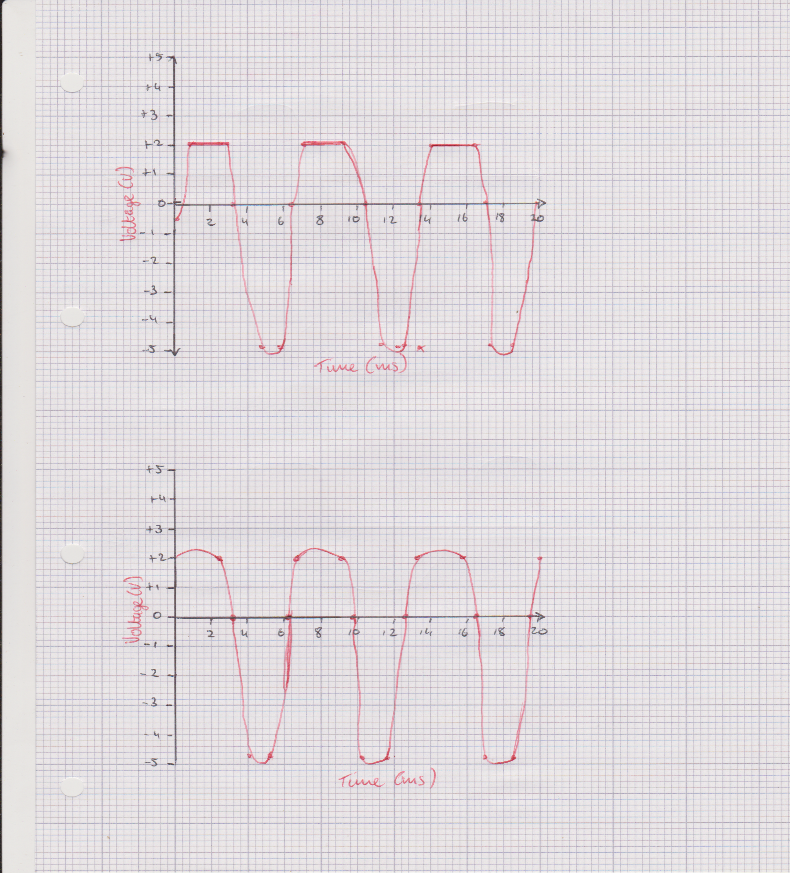

# Analysis (Part Two)

* **c)** When an a.c source and a d.c source are applied to the circuit in *Fig 2.1* it produces voltages as seen in the graph above. The voltage acts in a regular manner on the bottom half creating a sinusoidal wave as it increases and decreases. However, on the top half it levels off sharply and continues for a short period of time at a constant value.
* **d)** When the LED is placed in parallel as seen in *Fig 2.2* the sharp leveling as seen in **c)** is smoothened off and the voltage doesn’t continue at a constant value. Instead, it gradually increases in a somewhat sinusoidal manner also.

# Uncertainty and Error (Part Two)

* Errors when calibrating a zero reference for the oscilloscope
* Errors when choosing voltages and frequencies on the function generator
* Power lost through other energy conversions e.g heat
* Internal resistance of devices e.g the oscilloscope impacting readings

# Conclusions(Part Two)

* **a)** It can be determined that when an a.c source was applied to the circuit in *Fig 2.1* the voltage flowed normally in the bottom half of the graph (sinusoidal curve). Similar to Part One when the voltage changed direction the cut-in voltage came into effect and the curve levels off. However, this time with the new addition of the d.c source the cut-in voltage as seen on the graph is a much straighter line since the voltage is being supplied at a constant rate as opposed to the previous a.c.
* **b)** It is apparent that when the LED is placed in parallel as seen in *Fig 2.2* the voltage curve in the positive region around the cut-in voltage becomes more rounded. This shows that the LED had a greater cut-in voltage and as a result it “smoothened” the previous d.c voltage and in turn changed a previously d.c voltage to a somewhat a.c voltage.

# General Conclusions

* **Reverse and Forward Biased:** From this experiment it is clear that diodes have a cut-in voltage and only conduct current whilst in a forward biased state. When reversed biased the voltage will rise and fall in a sinusoidal curve as seen in the various oscilloscope diagrams throughout this experiment.
* **Diode Conduction:** By placing two diodes in parallel with the respective bias directions being opposite current can flow in both directions throughout the circuit in a somewhat a.c manner with a small change in voltage over the duration. However, there is a time interval between cut-in voltages in which zero current is flowing throughout the circuit.